WEEK 7

Mandatory Hands-On

**REACT**

**Creating an officespacerentalapp Application**

* *Officespacerentalapp* application is created in the directory Week7\ using the command *npx create-react-app officespacerentalapp.*

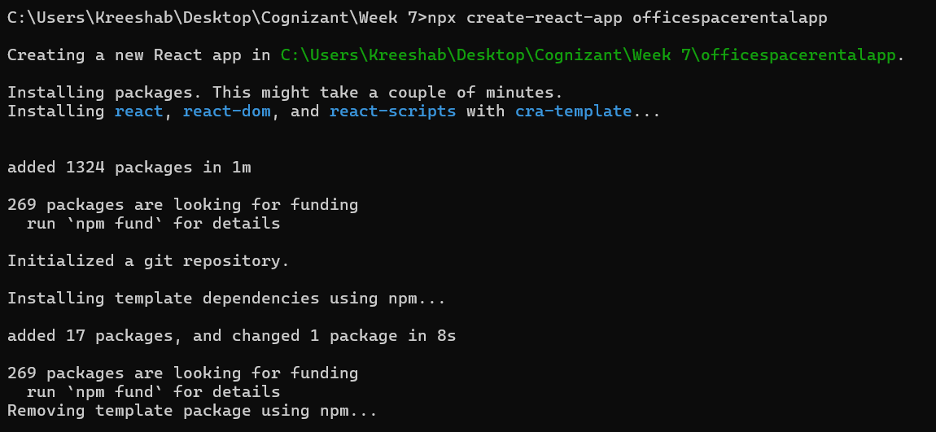

* Navigated to the React app and copied the required image to the src folder.

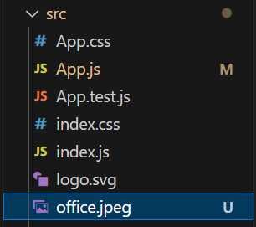

**App.js:**import Office from './office.jpeg';

import './App.css';

function App() {

  const element = "Office Space";

  const img = <img src={Office} width="25%" height="25%" alt="Office Rental" />;

  const Property = { Name: "DBS", Rent: 70000, Address: "Chennai" };

  return (

    <div className="App">

      <h1>{element}, @affordable prices </h1>

      {img}

      <h1>NAME: {Property.Name}</h1>

      <h1 style={{ color: Property.Rent <= 60000 ? 'red' : 'green' }}>

        RENT: {Property.Rent}

      </h1>

      <h1>ADDRESS: {Property.Address}</h1>

    </div>

  );

}

export default App;

**Sample Output:**

When rent less than 60000

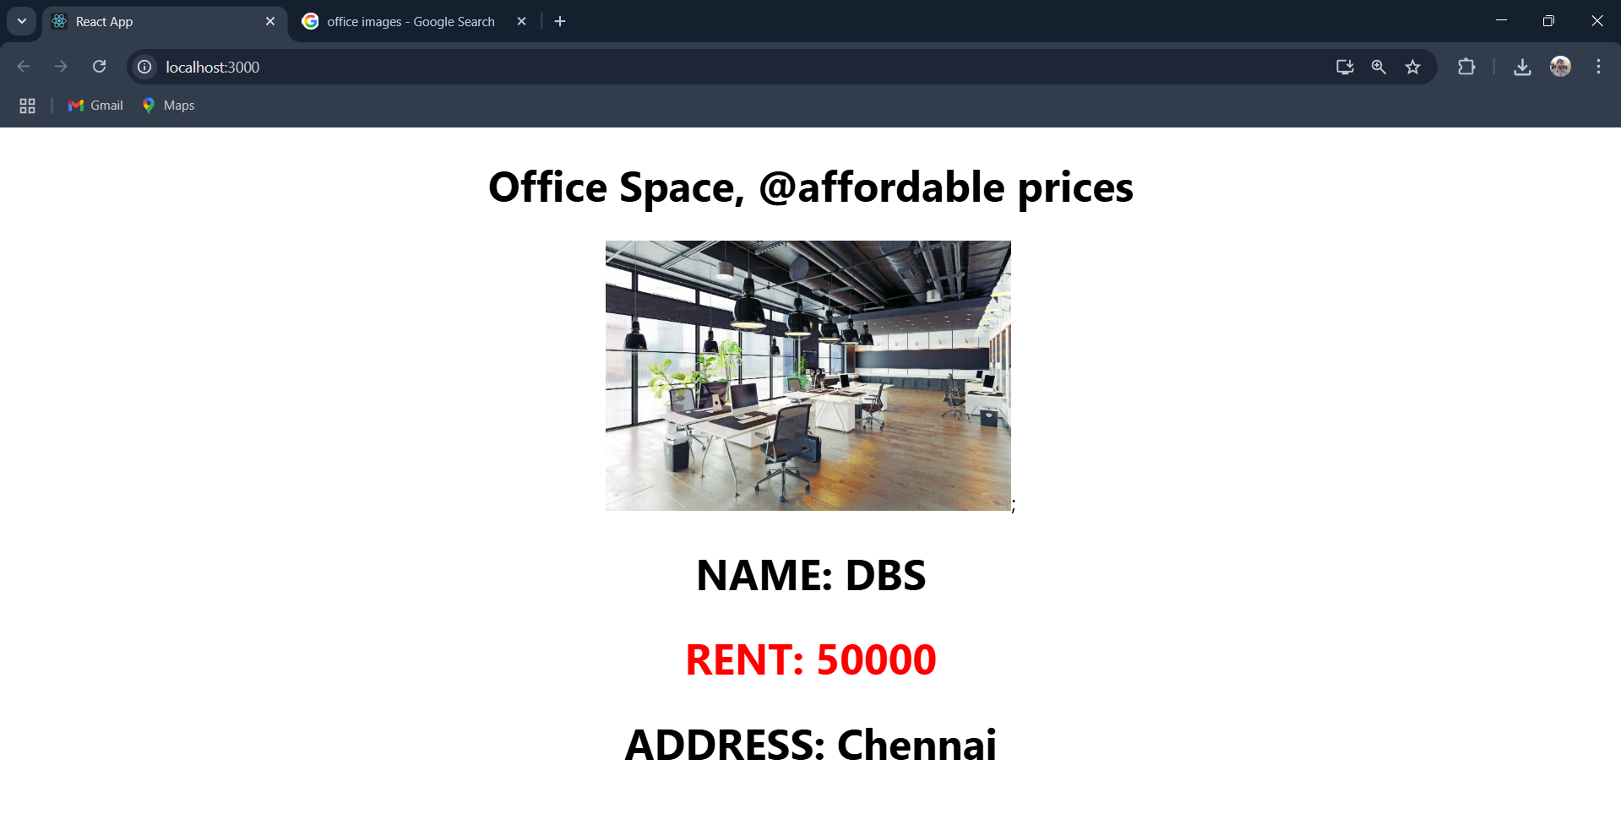

When rent more than 60000

